(Approx. 455 words)

myCharge Products
by George Harding, Treasurer, Tucson Computer Society
March 2019
www.aztcs.org

I received two products to review from myCharge.

HubMax

This is a modern charger about the size of a pocket notebook, about 4 ¼” X 7/8” X 3”. It is very compact and weighs about the same as my iPhone 7.

It has two attached connecting cables, one for iPhone (Lightning) and one for Android (microUSB). They fit snugly into the side of the case.
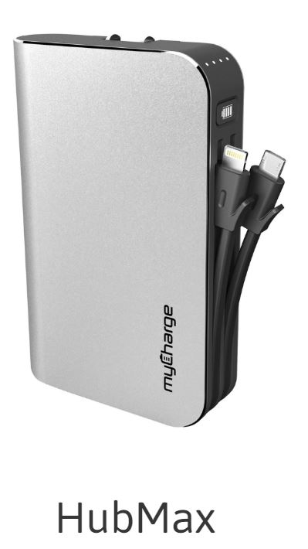
It is very easy to charge the internal battery. It comes with outlet plugs. All you do is flip the prongs out and push into a wall socket. Nothing could be easier!

There is a button on the side, near the top, which can be used to show the battery charge level. There are four LEDs that illustrate the level. The button is also used to start a device charging if it doesn’t start automatically.

You don’t need to worry about over-charging your device. Nor do you need to worry about over-charging the internal battery of the HubMax. That’s handled internally to make sure that no over-charging occurs.

There is also a USB port if you need to use a cable to charge your device.

The internal battery can charge many types of devices, up to and including a tablet. It is rated at 10,050 mAh, which the company describes as 5 or 6 times the usual battery capacity. You can charge up to 3 devices at a time, if you wish.

All myCharge products use the Lithium-Polymer batteries. See https://en.wikipedia.org/wiki/Lithium_polymer_battery and https://www.electronicdesign.com/power/what-s-better-battery-your-portables-li-ion-or-li-poly

The packaging includes the HubMax unit and an instruction manual. The manual is a card that briefly explains the features. You wouldn’t need anything else, since the unit is so simple to use.

The Company provides a one-year limited warranty.

RazorMega

This is a larger version of charger designed somewhat differently and with more power.
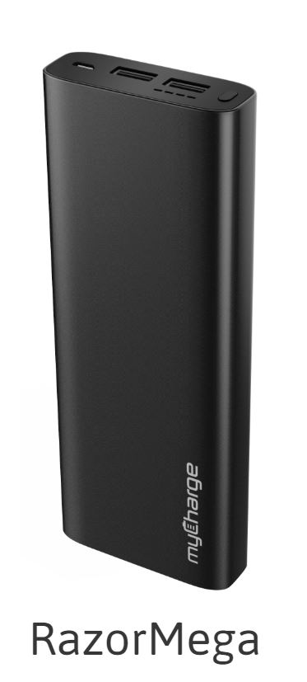
It has two USB-A ports for charging your devices and a micro-USB port for charging the internal battery.

As with the HubMax, there are four LED lights that show the degree of battery charge and a button to display them. The button can also be used to start charging your devices, if they don’t start on their own.

The size is larger, about 6 ¾” X 2 ½” X ¾” and is somewhat heavier as well.

This unit includes the same protection against overcharging the internal battery and your devices. When fully charged, the charge process is automatically stopped. The charging capacity is 20,000 mAh.

The packaging includes the unit, a charging cable and a manual card. While brief, the card tells you everything you need to know about its operation.

Hubmax and RazorMega mycharge.com
Price: Hubmax $100, RazorMega $70

